8-Day Lemosho Route Itinerary for Climbing Mount Kilimanjaro with Trust Tours and Safari Company.
Special Full Moon Climb – July 27-29, 2026

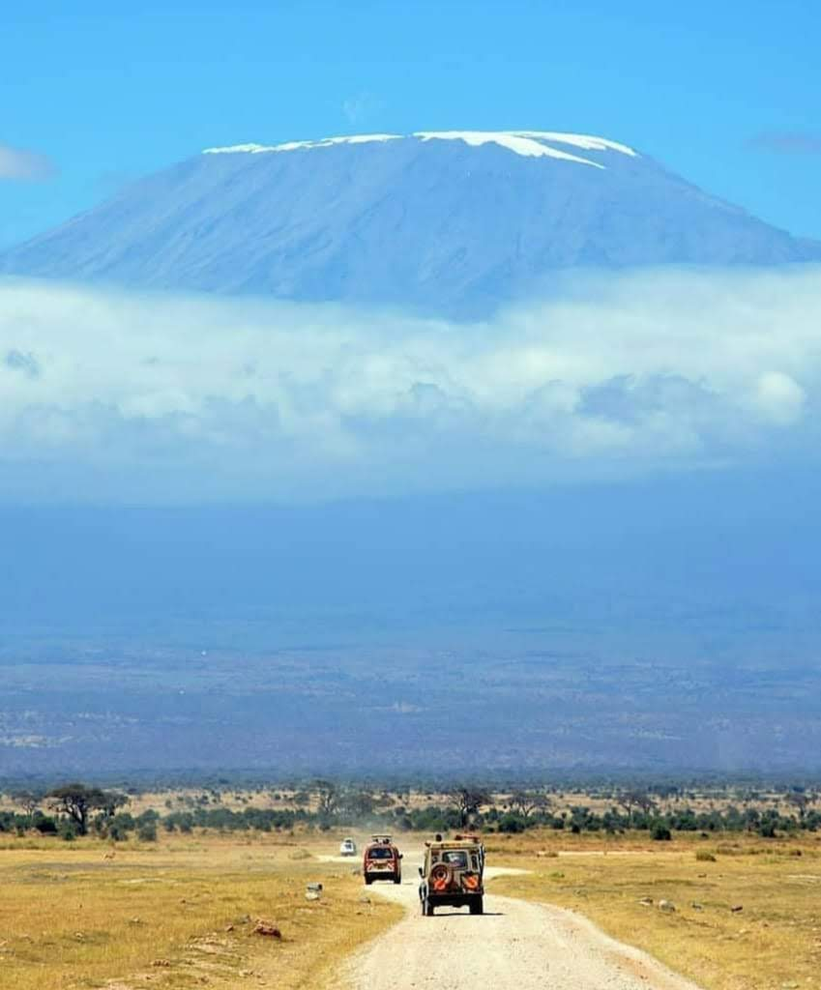
Climbing Mount Kilimanjaro during a full moon is a magical experience. The full moon illuminates the night sky, casting a surreal glow over the mountain and making the summit night even more unforgettable. Mount Kilimanjaro, the highest peak in Africa and one of the world’s most iconic mountains, is a dream destination for adventurers and nature enthusiasts alike. The Lemosho Route is widely regarded as one of the most scenic and less crowded paths to the summit, offering a perfect balance of breathtaking landscapes, diverse ecosystems, and ample time for acclimatization. Trust Tours and Safari Company has delighted designed this 8-day Lemosho Route itinerary to ensure that climbers have the best possible experience, with a high success rate and unforgettable memories. Below is a detailed breakdown of each day’s activities, including what to expect, the terrain, and the unique experiences you’ll encounter along the way. The program includes one night before the climb in Moshi and one night after in Arusha, for preparation for safaris that is why one night after the Kilimanjaro has to be in Arusha so we can make smooth to Tarangire national Park, ensuring a well-rounded experience. It’s suitable for adventurers seeking midrange services with accommodation and experienced guides. This itinerary provides a balanced combination of adventure and comfort, perfect for climbers seeking a guided, safe, and memorable experience.

Day 00: On Thursday, July 22, 2026, From KUL fly to Nairobi, Kenya on flight KUL-NBO D7 101. The flight will depart at 1900 and arrive at 2300 on the same day (RM999), Shuttle transfer can be arranged by request.

Day 1: Arrival in Moshi or Arusha: On Friday, July 23, 2026
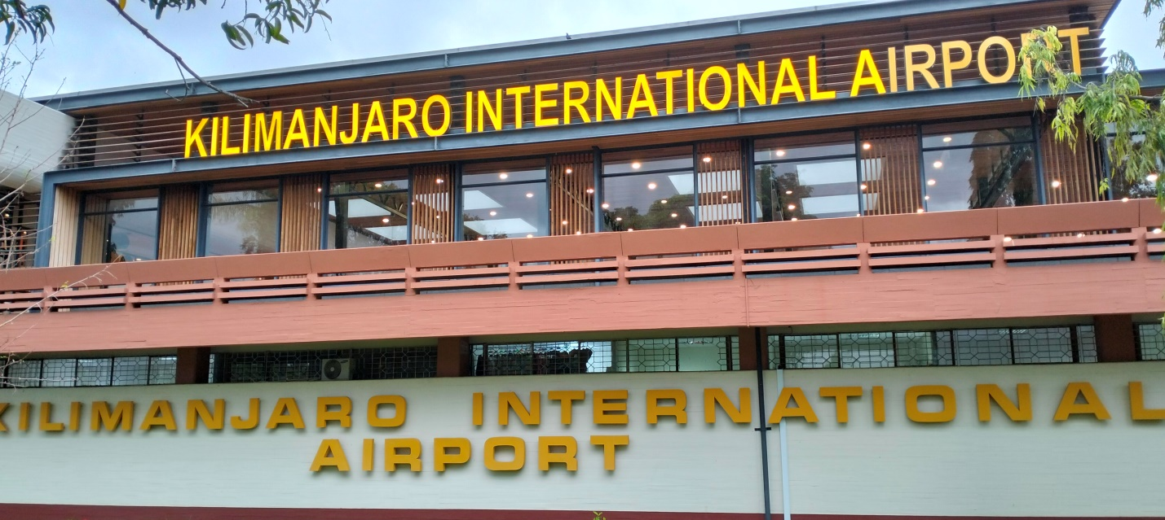
Your journey begins with your arrival at Kilimanjaro International Airport, where you will be warmly welcomed by a representative from Trust Tours and Safari Company. You will be transferred to your hotel in Moshi or Arusha, where you can relax and prepare for the adventure ahead. A pre-climb briefing will be conducted by your guide, who will provide you with essential information about the climb, including safety measures, gear checks, and an overview of the itinerary. This is also a great opportunity to ask any last-minute questions and ensure you are fully prepared for the challenge. Overnight stay at the hotel, where you can enjoy a delicious dinner and rest well before the climb begins.

Day 2: Londorossi Gate to Mti Mkubwa Camp: On Saturday, July 24, 2026
After an early breakfast, you will drive to the Londorossi Gate, the starting point of the Lemosho Route. Here, you will complete the necessary registration formalities and meet your support team, including porters and cooks. The trek begins with a gentle walk through the lush rainforest, home to a variety of wildlife, including monkeys and colorful birds. The trail is relatively easy, allowing you to ease into the climb while enjoying the serene beauty of the forest. After approximately 3-4 hours of hiking, you will arrive at Mti Mkubwa Camp (Big Tree Camp), where you will spend your first night on the mountain. The camp is situated at an altitude of 2,650 meters, and you will enjoy your first mountain meal prepared by the skilled camp chef.

Day 3: Mti Mkubwa Camp to Shira 1 Camp: On Sunday, July 25, 2026
On the second day of your climb, you will leave the rainforest behind and enter the heath and moorland zone. The trail becomes steeper, but the stunning views of the Shira Plateau make the effort worthwhile. You will pass through open grasslands and giant lobelias, with occasional sightings of unique alpine flora. The hike to Shira 1 Camp (3,500 meters) takes about 5-6 hours, and you will notice the air becoming thinner as you gain altitude. Upon arrival at the camp, you will have time to rest and enjoy the panoramic views of the surrounding landscape. The evening will be spent acclimatizing and preparing for the next day’s trek.

Day 4: Shira 1 Camp to Shira 2 Camp: On Monday, July 26, 2026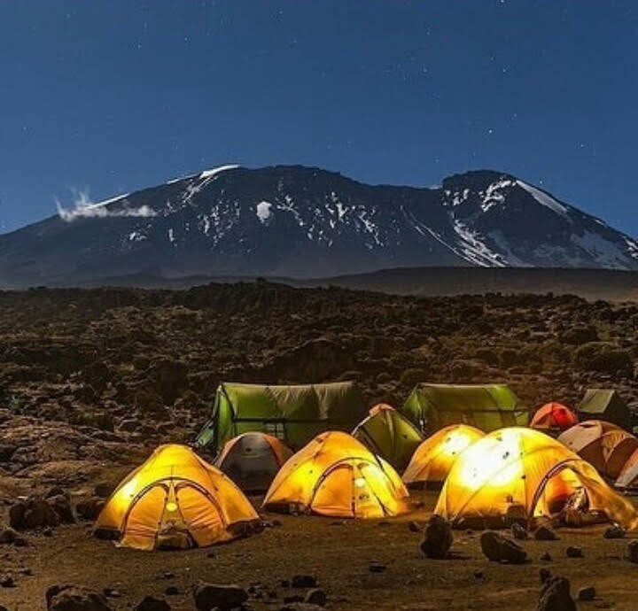
This day involves a relatively short hike, allowing for better acclimatization and exploration of the Shira Plateau. The trail is gentle and offers spectacular views of Mount Kilimanjaro’s peaks, including Kibo and Mawenzi. You will also pass by the Shira Cathedral, a stunning rock formation that adds to the dramatic scenery. The hike to Shira 2 Camp (3,850 meters) takes about 3-4 hours, leaving you with plenty of time to relax and enjoy the high-altitude environment. This camp is known for its breathtaking sunsets and clear night skies, making it a perfect spot for stargazing.

Day 5: Shira 2 Camp to Barranco Camp: On Tuesday, July 27, 2026
Today’s trek is one of the most scenic and rewarding days on the Lemosho Route. You will ascend to Lava Tower (4,600 meters), a prominent landmark on the mountain, where you will stop for lunch. This part of the hike is crucial for acclimatization, as you will climb high and sleep low, helping your body adjust to the altitude. After lunch, you will descend to Barranco Camp (3,900 meters), passing through the unique alpine desert landscape. The camp is nestled in the shadow of the Barranco Wall, which you will tackle the following day. The descent to Barranco Camp takes about 2-3 hours, and you will be rewarded with stunning views of the surrounding valleys and peaks.

Day 6: Barranco Camp to Karanga Camp: On Wednesday, July 28, 2026
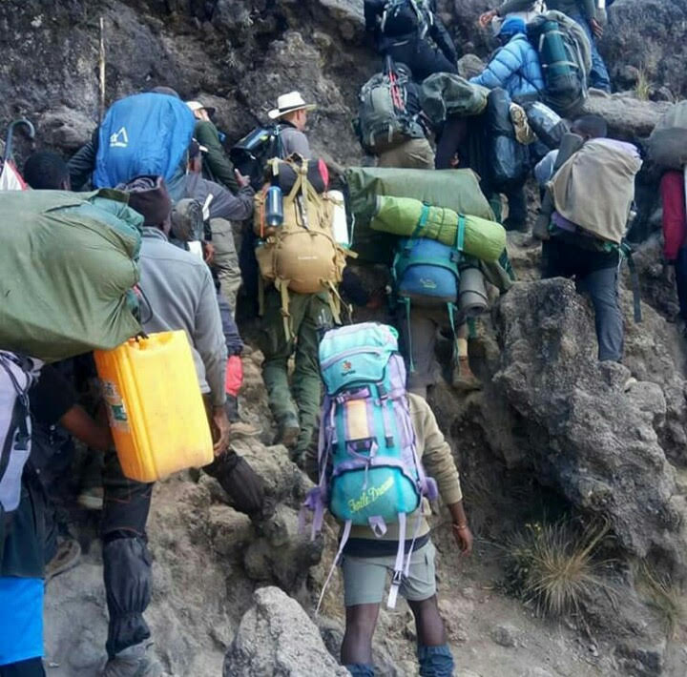
The day begins with a challenging but exhilarating climb up the Barranco Wall, a steep section that requires some scrambling but is manageable with the assistance of your guides. Once you reach the top, you will be rewarded with breathtaking views of the surrounding landscape. The trail then continues through rolling hills and valleys, with occasional stops to rest and take in the scenery. The hike to Karanga Camp (3,960 meters) takes about 4-5 hours, and you will arrive in time for a hot lunch. The camp is located in a picturesque valley, and the afternoon can be spent resting or exploring the area.

Day 7: Karanga Camp to Barafu Camp: On Thursday, July 29, 2026
Today’s trek is relatively short but steep, as you make your way to Barafu Camp (4,670 meters), the base camp for your summit attempt. The trail takes you through a rocky and barren landscape, with stunning views of the summit looming ahead. The hike takes about 3-4 hours, and upon arrival at Barafu Camp, you will have an early dinner and rest in preparation for the final push to the summit. Your guide will provide a detailed briefing on the summit night, including what to expect and how to prepare. It’s important to get as much rest as possible, as you will be waking up around midnight to begin the ascent. 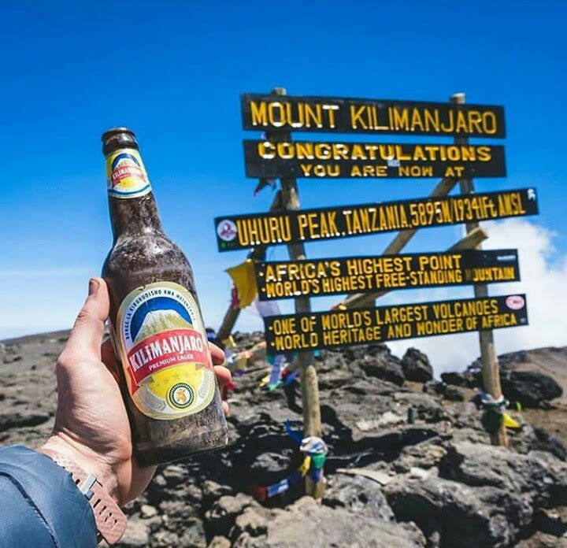

Day 8: Summit Day – Barafu Camp to Uhuru Peak to Mweka Camp: On Friday, July 30, 2026
Summit day is the most challenging but rewarding part of the climb. You will wake up around midnight and begin the ascent in the dark, guided by your headlamp. The trail is steep and demanding, but your guide will set a steady pace to ensure you reach the summit safely. After approximately 6-7 hours of hiking, you will arrive at Stella Point (5,739 meters), where you will be rewarded with the first light of dawn and stunning views of the surrounding glaciers. From here, it’s a short but exhilarating walk to Uhuru Peak (5,895 meters), the highest point in Africa. After celebrating your achievement and taking photos, you will begin the descent back to Barafu Camp for a short rest before continuing to Mweka Camp (3,100 meters). The descent is long and tiring, but the sense of accomplishment will keep you going.

Day 9: Mweka Camp to Mweka Gate and Return to Moshi or Arusha: On Saturday, July 31, 2026
On the final day of your climb, you will descend through the rainforest to Mweka Gate, where you will receive your summit certificates and bid farewell to your support team. The descent takes about 3-4 hours, and upon arrival at the gate, you will be transferred back to your hotel in Moshi or Arusha for a well-deserved shower and celebration. Trust Tours and Safari Company will also organize a farewell dinner to celebrate your successful climb and share stories of your adventure.

Why Choose Trust Tours and Safari Company?
Trust Tours and Safari Company is committed to providing a safe, enjoyable, and unforgettable climbing experience. With experienced guides, a well-trained support team, and a focus on acclimatization, safety, and comfort, we ensure that our clients have the best chance of reaching the summit. Our 8-day Lemosho Route itinerary is designed to maximize your chances of success while allowing you to fully appreciate the beauty and diversity of Mount Kilimanjaro. Book your climb with us today and embark on the adventure of a lifetime!

Price Pax US$ 2,299 per single occupancy all-inclusive in groups

What is included Kilimanjaro Package.

Transfers:
- Pick-up and drop-off at Kilimanjaro International Airport;
- Transfer to the trailhead - entry gate to Kilimanjaro National Park;
- Pick-up at the exit from Kilimanjaro National Park and transfer to the hotel;
Entry fees:
- All park fees collected by the Kilimanjaro National Park (conservation fees, camping fees, crew fees, vehicle fee, rescue fee and all other fees collected by the Tanzania National Parks Authority).
Accommodation:
- One night at 4* hotel ( SG Premier Resort or The Arusha Hotel) before the expedition and one night after; The hotels have everything for your comfortable stay - caring staff, nice rooms, reliable Wi-Fi, restaurant and swimming pool);
- Tented accommodation on Mount Kilimanjaro.
Please note:
All accommodation is on sharing basis (i.e. you will be sharing with your travel companion a twin/double room in the hotel and a tent during the hike. If you travel alone, we will match you with a same-sex adventurer).
Meals:
- Breakfast in the hotel before and after the hike;
- All meals on the hike. Our Kilimanjaro diet includes energy-rich and highly nutritious meals prepared by our professional high-altitude cooks. A typical diet on Kilimanjaro includes different soups, garnishes, several types of fish and meat, fresh fruit and vegetables; vegetarian/gluten-free/halal options are available at no extra cost;
- All drinks on the hike (coffee, tea, hot chocolate and water).
Hiking and safety equipment
- 4-inch (10-cm) thick and comfortable sleeping mats;
- All group equipment (spacious and comfortable dining tent, camping table and chairs, crockery and cutlery);
- Oxygen cylinders and oximeters;
- GPS-tracking service;
- Complete medical kits.
Climbing crew:
- Professional guides, licensed by Kilimanjaro National Park. All our guides are the holder of Wilderness First Responder or Wilderness First Aid certifications. All our guides have 7+years of successful mountaineering experience;
- Dedicated support crew (assistant guides, camp master, porters, cooks, etc.).

Kilimanjaro Excludes:

Kilimanjaro Price Excludes:

- Local airfares, International airfares.
- International Travel insurance
- Tanzania Visa: $50 per person on arrival.
- Alcoholic and non-alcoholic drinks.
- Lunch and dinner at the hotel (before and after the ascent);
- Personal Expenses (e.g. laundry, telephone, beverages, etc.)
- Meals not listed above on those arrival and departures days
- Mandatory tips for guides, porters, and cooks typically range from US$200 to US$350 per hiker. This amount can vary based on the number of days, the number of hikers in the group, and the chosen route.
- Items of personal nature.
- Currently, the cost of portable toilets is not included in the tour package to reduce trip expenses.
- Public restrooms are available in camps along the way. However, for those who prioritize comfort, renting a portable toilet is highly recommended, $270 for entire trip.
- NB: Tips should be submitted to the office.
How Many Porters Are Required to Conquer Kilimanjaro?
Are you ready for the ultimate adventure of conquering the mighty Kilimanjaro? Well, dear adventurer, get ready to embark on this breathtaking journey with us! We have meticulously planned every detail to ensure your expedition is flawless. Just imagine this wonderful scenario: throughout the trek, you will be accompanied by your own personal porter who is not only fiercely loyal but also incredibly courageous. They will take care of carrying all your gear, from essential trekking items to even your cooking equipment! And guess what? If you crave the luxury of a private bathroom during your expedition, fear not; your dedicated porter will make sure it's right there with you. Get excited because a world of adventure awaits you!

NO. OF CLIMBER NO OF PORTERS
1 Climber 3 To 4 Porters
2 Climbers 5 To 6 Porters
3 Climbers 8 To 9 Porters
4 Climbers 11 To 12 Porters
5 Climbers 12 To 15 Porters
6 Climbers 17 To 18 Porters

But, let me assure you, we don't settle for just being adequate! We are here to cater to your every need with utmost care. Should you have any specific requirements, we will assign an additional porter to provide unwavering support. No request is too big for us to handle!
Dear explorer, we understand the challenges our hardworking porters may face. There is a limit to the weight they can carry, to ensure their well-being. However, be rest assured that as a top-notch company, we maintain an exceptional porter-to-client ratio. This means our brave companions can efficiently fulfill their duties, guaranteeing you the best possible experience.
You can relax knowing that we are dedicated to meeting all your needs diligently and with enthusiasm.

PAYMENT PLAN:
Payment according to the Schedule should be made;
Date Due | Description
- First Payment will be done online upon Booking.  - Full Payment will be done by cash on your arrival at airport or hotel. | Full amount of 10%.  Full amount of 90%.

BANK DETAILS:

Account Holder: Trust Tours and Safaris Company Limited
Account Number: 0110013634 for USD $
Involved Bank: Exim Bank (T) Limited
Postal address: Box 1431
9, Samora Avenue, Dar es Salaam Tanzania
Swift Code : EXTNTZTZ
Chips UID : 370780
Note this; Bank charges & Transaction You Must Clear for 100%, No Deduct into Trust Tours And Safaris Company Limited.

